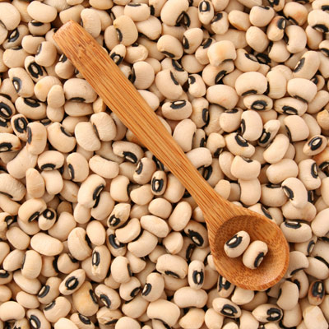
Fresh or Frozen Black Eye Peas or Cream Peas

2 slices of bacon cut up and fried till crisp
1 medium onion chopped medium
1 quart frozen or fresh peas
1 large garlic clove chopped
½ cup chopped green pepper
1 large stalk celery sliced with leaves
1/2 cup chopped cilantro
1 cup canned tomatoes or home grown ones
1 tsp or more of salt to taste
1/2 tsp pepper

Sauté onion, garlic, pepper, celery in bacon fat, add about 2 cups water, add peas, salt, pepper and herbs provence. After boiling turn down to medium or low and cook slowly about 20-30 minutes until peas are tender, adjust seasoning. After cooking 15 minutes add chopped cilantro. Let sit 10 minutes or so to let flavors mingle.
(submitted by Sandy Llewellyn)

