

**Great Salads**

Great salads should have different colors, tastes, and textures.

[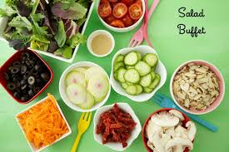](http://www.google.com/url?sa=i&rct=j&q=&esrc=s&source=images&cd=&cad=rja&uact=8&docid=5dtx3MGtO_NvWM&tbnid=0Jy_SHcuE88KNM:&ved=0CAUQjRw&url=http://weelicious.com/category/salads/&ei=jRYdU_-iM8O32wX1hYHQDw&bvm=bv.62578216,d.b2I&psig=AFQjCNFupjZpJsSq5LtcQgHqTQC-iJ7Hrg&ust=1394501407325327)

Start with lettuce of several shapes and colors and textures. This should make up 2/3 of volume of salad but not by weight.

Add some arugula in small or large amounts depending on your taste or fresh basil, mint or cilantro.

Add at least 5 vegetables such as sliced celery, carrots, green or red pepper, radishes, jicama in matchstick slices, sliced onion white or purple, thin sliced cabbage green or purple, fresh mushrooms and of course good tomatoes.

Consider adding fruits in small amounts and usually one kind such as apples, pears, strawberries, blueberries, grapefruit, or orange slices.

Use a good olive oil to coat salad and then add the salad dressing.

[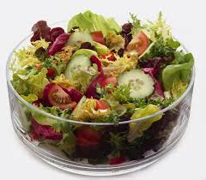](http://www.google.com/url?sa=i&rct=j&q=&esrc=s&source=images&cd=&cad=rja&uact=8&docid=jusMZPKacrcDoM&tbnid=yySwrURWvJWCSM:&ved=0CAUQjRw&url=http://circlescafe.com/gallery/salads/&ei=KfIdU-DnHca92wWb44GIBw&bvm=bv.62578216,d.b2I&psig=AFQjCNGc_bjbT0QgYDQRN9mhXUB0SsIgLw&ust=1394557857214492)Sprinkle with feta if desired.

**Homemade Honey Mustard Salad Dressing**

Makes 1 pint

1 3/4 cup Apple Cider Vinegar

3 grated cloves garlic

1/4 cup honey or less to taste

About 4 tablespoons brown mustard

2-3 teaspoons Spike (HEB has it in the spice section)

Mix honey, mustard, finely grated garlic, spike, and honey together in a pint jar; stir in a little vinegar to mix then add rest of vinegar and shake. Adjust for sweetness based on your taste. It doesn't need refrigeration but can keep in refrigerator if wanted.