**Green Beans**

[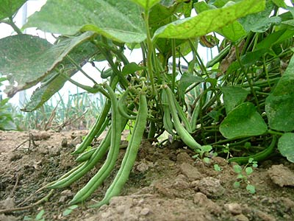](http://upload.wikimedia.org/wikipedia/commons/9/9e/A_green_bean.jpg)Do you have a bumper crop of green beans? These vegetables are easy to grow from vines or bushes, and regular picking insures a long and steady supply. For a vegetable that was not readily available until the late nineteenth century, we have come up with a lot of ways to serve them. Green beans can be boiled, and then seasoned with salt and pepper to taste; a dash of lemon juice can brighten the taste while balsamic vinegar will make the taste deeper and more "green". Old southern cooks fry bacon pieces to render the grease, add a small amount of onion and tomato to sauté in the grease, then warm boiled green beans for a distinctive taste. Modern cooks toss them with salt, pepper, and olive oil and roast them or dip them in a batter like onion rings and fry them.

A quick review of some of the latest cookbooks shows that the world really appreciates this lowly vegetable. Germans add green beans to soup made with leeks and Northern beans. Czechs toss green beans with slivers of onion and a dressing of sour cream, mayonnaise, and horseradish. According to one TV chef, Mexican food can be complemented with a side dish of green beans brightened with lime juice and onion slivers tossed with a salad dressing of olive oil and tomatillo salsa. Italians dine on a simple dish of green beans tossed with balsamic vinegar, salt, pepper and finely chopped black olives.



All of this got me to check the garden and start trying to come up with a dish that Texans might appreciate. The vegetables that are required are in season now.

1 Roma tomato, chopped (about 1/2 cup)

4-5 green onions, chopped (about 1/2 cup)

1-2 small bell peppers, chopped (about 1/2 cup)

1 jalapeno, seeded and chopped (about 1 Tablespoon)

4-6 sprigs of cilantro or flat-leaf parsley (about 2 Tablespoons)

1-2 key limes

1 Tablespoon olive oil

Salt and pepper

1 lb. green beans, with strings and ends removed (about 4-5 cups)

Mix the tomato, green onions, bell pepper, jalapeno, cilantro and the juice of one lime. Add salt and pepper to taste, and set aside to let the flavors mix. Steam the green beans for 4-7 minutes or until crisp yet tender when tested with a fork. Cool beans, then dress with the juice of the remaining lime, olive oil, salt and pepper. When ready to serve, toss the two mixtures together for a salad. Black olives and sour cream garnish are optional.