This is easy to make, uses few ingredients and taste wonderful. Who would know it is tomatoes when spread on toast or used as a glaze on baked or grilled chicken, fish, or pork. Try it as a topping for vanilla ice cream. Make sure you use low or no sugar pectin or it will not set. I did peel and core the tomatoes but did not remove seeds or pulp. Use lots of Basil.

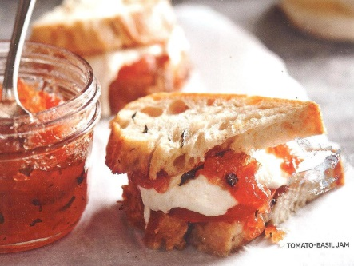
Tomato-Basil Jam

2 ½ pounds ripe tomatoes, peeled
¼ cup lemon juice
3 T. snipped fresh basil
3 cups sugar
1-- 1.75 oz. package powdered fruit pectin for lower-sugar recipes or 3 T. powdered fruit pectin for low or no sugar recipes

- Seed, core, and finely chop tomatoes. Place 3 ½ cups chopped tomatoes in 6-8 qt. stainless steel, enamel, or nonstick heavy pot. Bring to boiling, stirring occasionally; reduce heat. Simmer, covered for 10 min. Measure out 3 ½ cups tomatoes; return to pot. Stir in lemon juice and basil.
- In a small bowl combine ¼ cup of sugar and the pectin; stir into tomato mixture. Bring to full rolling boil, stirring constantly. Stir in remaining 2 ¾ cups of sugar. Return to full rolling boil, stirring constantly. Boil hard for 1 minute, stirring constantly. Remove from heat and quickly skim off foam with a metal spoon.
- Ladle hot jam into hot sterilized half-pint canning jars, leaving a ¼ headspace. Wipe jar rims; adjust lids and screw bands.
- Process filled jars in a boiling-water canner for 5 minutes (start timing when water returns to boiling. Remove jars from canner; cool on wire racks.

Makes 5 half-pints.
Per tablespoon: 39 cal., 0 g fat, 0 mg chol., 4 mg sodium, 10 carb., 0 g fiber, 0 g pro.
From Better Homes and Gardens “Canning, Preserving, Freezing, Drying”. Jan Miller, editor.

(Submitted by Sandy Llewellyn)

