 

As the Garden Grows

A Publication of the Gonzales Master Gardeners

Gonzales, Texas December 2017 Volume 7, Issue 11



**Volunteer of the Year Award**

In case you missed the Winter Social on December 7, GMG announced the Volunteer of the Year Award. This year, the board of directors chose two recipients for this well deserved award. Carolyn Parratt and Shirley Frazier were this year’s recipients. They both have been very active in GMG activities throughout the year. Dedication to the various Master Gardener activities and service to the organization by the pair has not gone unnoticed. Their support and willingness to volunteer in the many areas of our program is much appreciated. A Big Thank You to both of you.

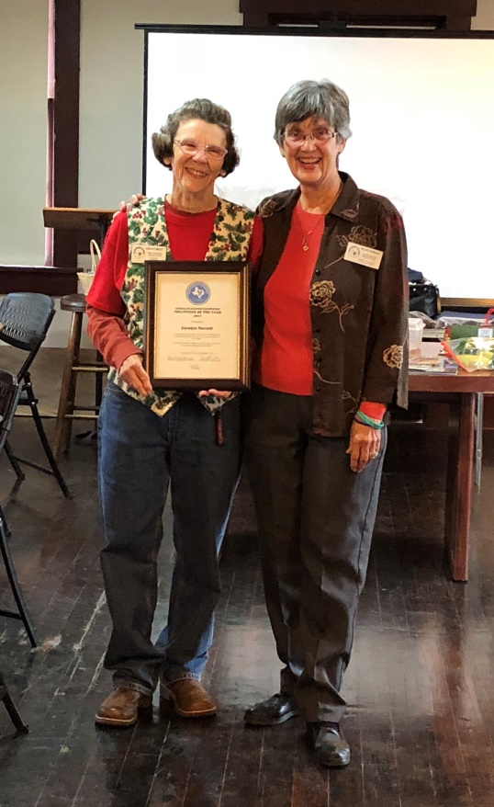



**Annual Dues and Recertification for GMG**

**One last reminder! Annual Dues of $20.00 are now due.**

**Please send a check or cash to Nick Wentworth, treasurer, ASAP.**

**Thanks.**



**Recipes We Like**

There is a section on our Website at [www.gonzalesmastergardeners.org](http://www.gonzalesmastergardeners.org) where we can post “Recipes We Like”. So many of us like to cook and we need to share our recipes with everyone. We had some great pot luck recipes at our Winter Social and everyone is asking for them. Please send those recipes to Jo Swiger, web master, so that she can post them for everyone to see.



**Third Grade Black Walnut Tree Conservation Program**

**Due to the cold rains on December 6, the third graders were not able to come to PACE for their program. It has been rescheduled for Friday, December 15. Please contact Donna Bell ASAP if you can help with the class. Be at PACE by 7:30 am. The program should finished by noon. Thank you.**



**Children’s Garden**

Stay tuned for more information on the progress at the Children’s Garden. Arline and a few volunteers have been working hard at maintaining the garden beds the past few months. They are looking great. Some much needed work on building/replacing flower beds and preparing them for the first grader’s planting sessions is in the works for January. The first classroom session with the first graders is **January 11**. Please let Arline know if you are available to volunteer for the program.



**Spring Plant Sale News!**

**Save the Date**



**Gonzales Master Gardeners**

**8th Annual Spring Plant Sale**

**Where: Texas Heroes Square**

**When: Saturday, March 24, 2018**

**Time: 8:30 am – 1:00 pm**

March 24th will be here before you know it! Stay in touch with your grow team leader to know when to start planting those seeds and propagating new plants. The Greenhouse is almost full of plants already. What are you bringing to the Plant Sale? There will be plenty of other opportunities to help out in the coming New Year. This is our biggest fundraiser for the year and we need all of you to participate.



**Plant of the Month**

NOTE: If you are interested in continuing this feature for the newsletter, please contact Fran Saliger.



**Area Events**

NOTE: If you are interested in continuing this feature for the newsletter, please contact Fran Saliger

Check out www.txmg.org for events around the state

New Braunfels area: http://txmg.org/comal/events

Austin Area: http://aggie-horticulture.tamu.edu/travis/

San Antonio, Texas- http://www.bexarcountymastergardeners.org



**Keep Informed!**

**www.gonzalesmastergardens.org**

**DATES TO REMEMBER: (Check elsewhere in newsletter for details)**

**Unless otherwise noted, all meetings/classes are at**

**623 N. Fair Street (Plantatarium: A Center for Exploration-aka PACE)**

|  |  |  |  |  |  |  |
| --- | --- | --- | --- | --- | --- | --- |
| **Sunday** | **Monday** | **Tuesday** | **Wednesday** | **Thursday** | **Friday** | **Saturday** |
| **DECEMBER 10** | **11** | **12**  **MG Class-Fruit Production-Gail Johnson**  **8:30-12:30**  **SPS mtg. 12:30** | **13** | **14** | **15**  **3rd grade Black Walnut Project 7:30-noon** | **16** |
| **17** | **18** | **19** | **20** | **21** | **22** | **23** |
| **24** | **C:\Users\mgfsaliger\AppData\Local\Microsoft\Windows\INetCache\IE\8LFJ7JVV\merry-christmas-isolated[1].jpg25** | **26** | **27** | **28**  **Board Meeting**  **9:30 am** | **29** | **30**  **Volunteer Hours Due** |
| **31**  **C:\Users\mgfsaliger\AppData\Local\Microsoft\Windows\INetCache\IE\54A9D70P\free-happy-new-year-clipart-images-3[1].jpg** | **JANUARY 1** | **2** | **3** | **3 Noon GMG Lunch Meeting** | **5** | **6** |
| **7** | **8** | **9**  **MG Class- How to Plant a Tree and Tree Diseases – Mark Kroeze**  **8:30-12:30** | **10** | **11**  **First Grade-Class Session #1** | **12** | **13** |
| **14** | **15** | **16** | **17** | **18** | **19** | **20** |
| **21** | **22** | **23 MG Class- Vegetable Gardening – Dr. Larry Stein**  **8:30-12:30** | **24** | **25**  **First Grade-Class Session #2** | **26** | **27** |
| **28** | **29** | **30 MG Class- Landscape Concepts and Design – Wendy Lovejoy 8:30-12:30** | **31** | **FEBRUARY 1 Noon MG Lunch Meeting** | **2** | **2** |



**Editors:** Texas A&M AgriLife Extension Office

Fran Saliger 1709 E. Sarah DeWitt Drive

[fsaliger@gvec.net](mailto:fsaliger@gvec.net) Gonzales, TX 78629

Charlotte Knox Phone: 830-672-8531

lotteknox@aol.com Fax: 830-672-8532

E-mail: [gonzales@ag.tamu.edu](mailto:gonzales@ag.tamu.edu)

Web pages: <http://gonzalesmastergardeners.org>

http://gonzales.agrilife.org

[](http://www.google.com/url?sa=i&rct=j&q=&esrc=s&source=images&cd=&cad=rja&uact=8&docid=vxruiDrdFSx_YM&tbnid=JJ6QmQOat50BAM:&ved=0CAUQjRw&url=http://hdwallimg.com/beautiful/facebook-logo-wallpaper-full-hd.html&ei=2PPCU7CWEYij8QGGkYGABQ&bvm=bv.70810081,d.b2U&psig=AFQjCNEkdd2GnaEN6Yb3n5Hl_gsTsWimZw&ust=1405371718414268)



Extension programs serve people of all ages regardless of socioeconomic level, race, color, sex, religion, disability, or national origin. The Texas A&M University System, U.S. Department of Agriculture, and the County Commissioners Courts of Texas cooperating. Individuals with disabilities who require an auxiliary aid, service or accommodations in order to participate in this meeting are encouraged to contact the County Extension Office at 830-672-8531 to determine how reasonable accommodations can be made. The information given herein is for educational purposes only. Reference to commercial products or trade names is made with the understanding that no discrimination is intended and no endorsement by the Texas A & M AgriLife Extension